Solution Architecture

Date | 01 July 2026
Team ID | xxxxxx
Project Name | OptiCrop: Smart Agricultural Production Optimization Engine
Maximum Marks | 5 Marks

Solution Architecture Diagram:
Provide a high-level visual representation of your solution's architecture. Use the structural layout below as a template to map out your Presentation Layer, Application Layer, and Data Layer. Fill in the specific technologies and components for your project directly into the boxes to create your architectural diagram.

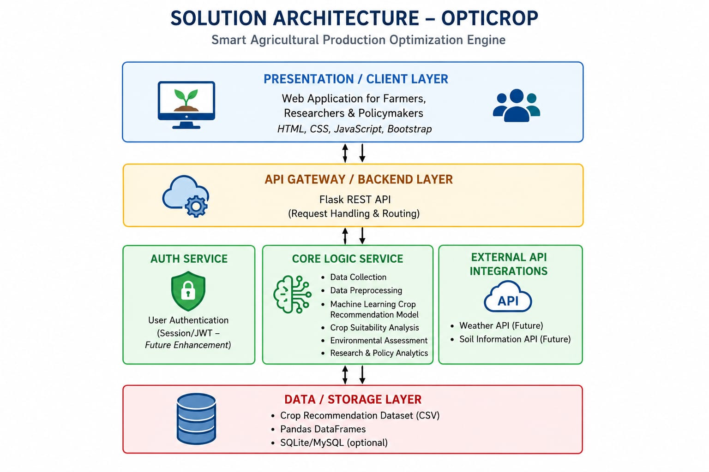

Component Description Table

Component Name | Description / Role in Architecture | Technologies Used
Presentation Layer | Collects soil inputs (N, P, K, pH, temperature, humidity, rainfall) and displays crop recommendations. | HTML, CSS, JavaScript, Bootstrap
API Gateway | Routes requests from the client to the backend services. | Flask REST API
Core Logic Service | Performs event analysis, topic extraction, conversation generation, history logging, feedback collection, and fact verification | Python, Scikit-learn, Pandas, NumPy
Database / Storage | Stores crop dataset, prediction data and application records. | CSV Dataset, SQLite/MySQL

